REGISTRATION
Student’s Name:

Student’s Grade:

Parent’s Name:

Telephone (Home):

Telephone (Work):

Emergency Contact:
(must be able to be reached during program hours)
Emergency Contact #:

Please circle the programs you are registering for:
Monday
***Homework Club
***Glitz and Glitter

Tuesday
***Homework Club
***Lego Robotics/Computer Programming
***Strategic Games/Chess Club
***Helping People

Wednesday
***Homework Club
***Woodturning
***Charlie Brown Music

Thursday
*** Homework Club

Friday
*** RC Cars at Twin Valley Elementary

Sunday
*** Silks

Extras
*** Active Club
***Breakfast Club

We ask that you contribute what you feel you
are able to assist Wings in covering
the costs of programs.
□ I am able to contribute $5.00-$10.00
□ I am able to contribute $15.00-$20.00
Please make checks payable to:
Wings Community Programs

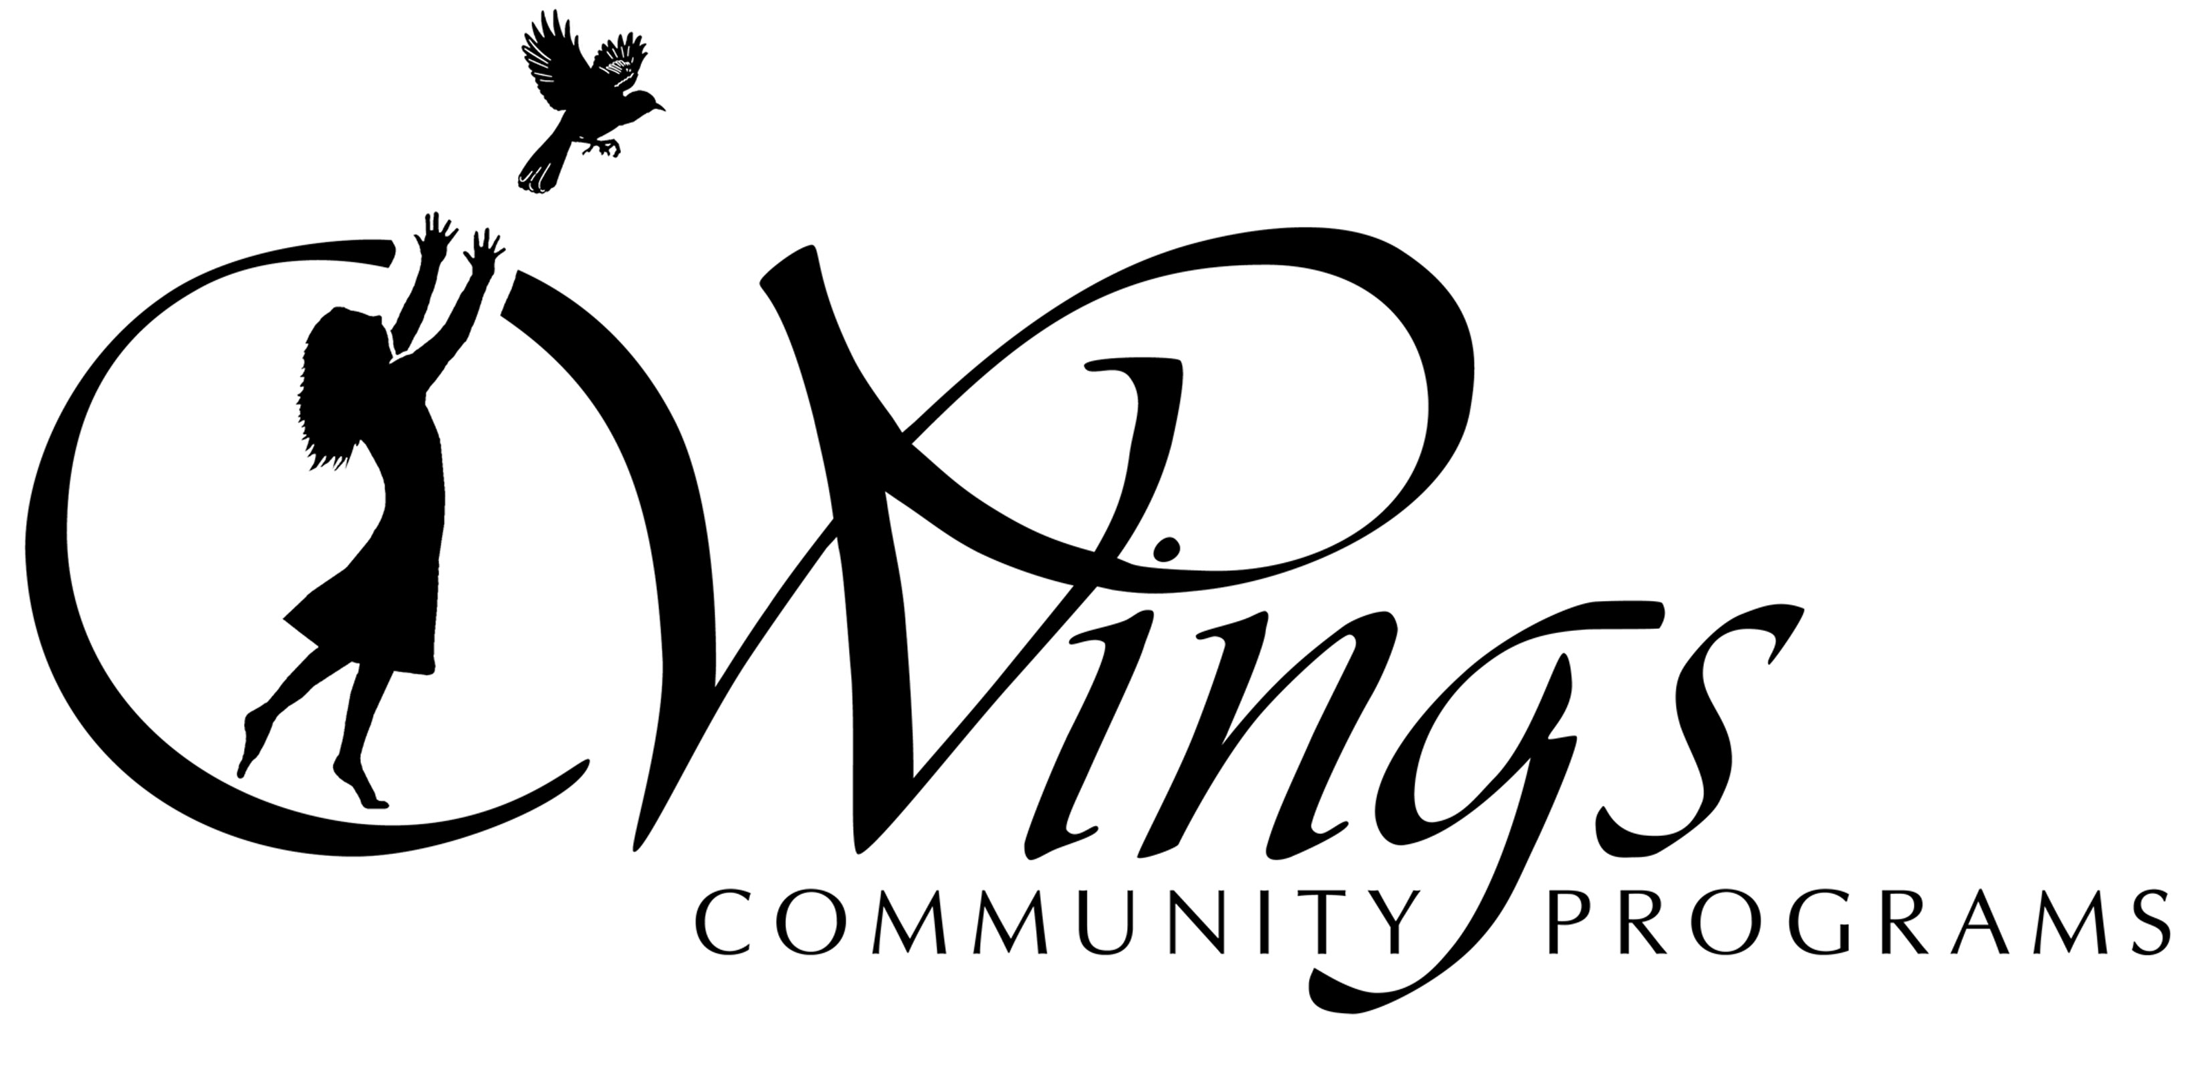_________________________________
Twin Valley Middle School
Session 4
Wings will begin on March 5th 2014!

This year’s programming schedule is as follows:
Session III: January 6th – February 14th (6 weeks)
Session IV: March 3rd– April 11th (6 weeks)
Session V: April 28th – May 30th (6 weeks)

Wings’ fee structure is intended to encourage families to contribute what they can afford. It is designed to allow you to make the decision as to that amount. WINGS suggests a contribution of $20 per program. We realize that when your child enrolls in multiple programs, and/or you have more than one child enrolling in programs, the suggested contribution may not be possible. We leave the decision to you. Please contribute what you can to help Wings cover the cost of running after-school programs. Our primary goal is to have children attend after-school programs. Please do not let the suggested contribution deter you from enrolling your child/children.

Finally, please remember that programs will run until 4:30 and your child will need to be picked up promptly at that time or they may take the 4:45 MOOVER

Contact Information:
Samantha Ambrose
Site Coordinator
sambrose@wes-tvms.org
Telephone: School 368-2880 EXT 1036 Cell 203-912-9906

Wings Community Programs actively encourages parental support in all of its programs and activities. Parents and guardians are welcome
at all Wings sponsored events

Website: www.wingscommunityprograms.com
Wings Office: 368-0000

MONDAYS

**Homework Club
w/ Mrs. Gould
Get that homework done and out of your way! Mrs. Gould is going to help you finish your homework and be on your way!

**Glitz and Glitter
w/ MS. Sandy Crowningshield
Join Sandy to learn how to make beautiful jewelry with glitz, glitter and style! From beads, to the rainbow loom you will make some fabulous things!!

TUESDAYS
**Homework Club
w/ MRs. Cunningham

Don’t let homework get you down!

Get that homework done and out of your way! Ms. Cunningham is going to help you finish your homework.

** Lego Robotics/ Computer Programming
w/ Mr. Styles

Learn beginning computer programming with Mr. Styles! He can help get you started with some simple programming techniques, or help you expand your knowledge. This session we will be adding Lego Robots into the mix!!

** Strategic Games/Chess Club
w/ Mr. salway
Learn how to play chess and play it well enough to win! We will also be learning other strategic games like Risk, Stratego, Carcassone and others! Bring your mad game skills and come ready to play!

**Helping People
w/ MS. Sandy Crowningshield

Helping people and animals in your community can be fun and rewarding. In this program as a group you will choose a common goal to help your community. Earn extra karma points, meet new people and animal friends!!
WEDNESDAYS
**Homework Club
w/ Mrs. Gould

Don’t let homework get you down!
Get that homework done and out of your way! Mrs. Gould is going to help you finish your homework.

**Charlie Brown Music
w/ MS. Maddern
Are you interested in participating in the school musical this year? Get a step up for the auditions by joining Ms. Maddern to learn the music for Charlie Brown! This program will meet on Tuesdays when there is a half day Inservice.)

** Woodturning on the Lathe
w/ Mr. Brower

The Lathe is a machine that makes round objects. Join us and learn how to make a bowl, candle holder and the last project will be something special.
Limit of 4 students
Grade 7 and 8 only

THURSDAYS
**Homework Club
w/ Mrs. Gamache
You’ve made it half way through the week and that paper still isn’t done! Don’t fear Mrs. Gamache can help!

FRIDAYS (AT TVES)

**RC Cars
w/ Jody Boos

Ride over on the bus and have your parents pick you up at 5:00. Learn how to modify RC cars to accommodate different track conditions. You will also spend some time working on the track, maintenance and expansion. Girls and boys are welcome! There is limited space (3 students) so sign-up right away!!!

SUNDAYS (AT TVES)
Intermediate class 10-11:30, beginner class11:45-1:15.
Come flip and fly with us! Learn the basics of circus acrobatics in a safe environment. Students who show responsibility, body awareness, control, and a strong respect for safety will have the chance to try more daring moves like flipping, partnering, and soaring through the air. Everyone will increase his/her strength and agility, learning fun and difficult moves. If you stick with this activity throughout the sessions, you’ll have the chance to perform in the Wings musical in June. This class is for both boys and girls! Grades 3-8.

