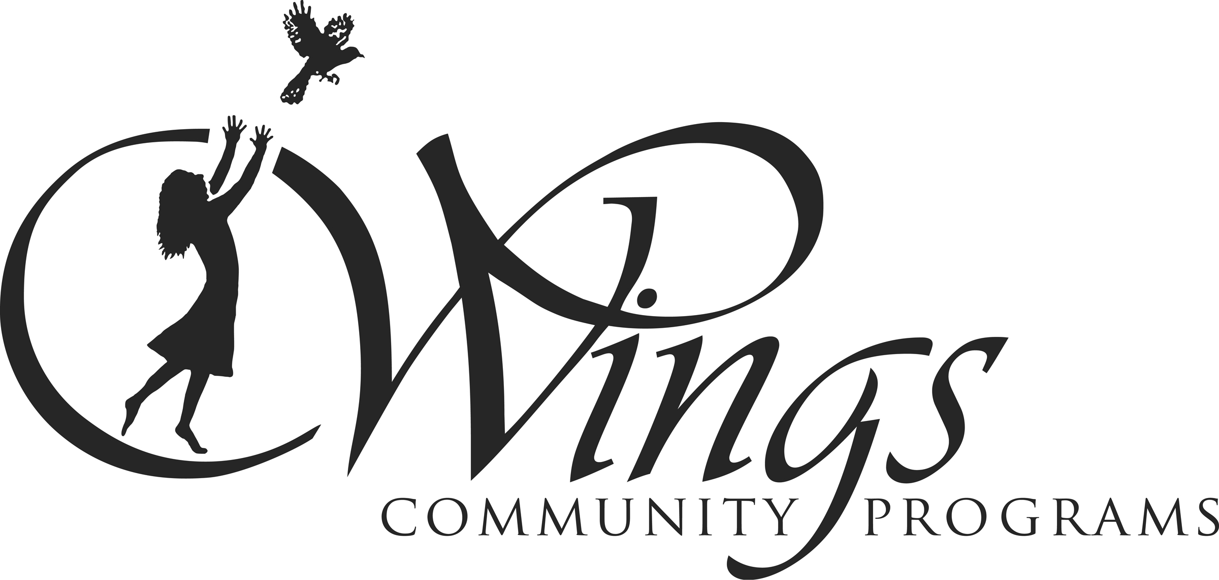

STIPEND AGREEMENT

The program leader/employee acknowledges that BEFORE the program can start, all paperwork has been completed with the WSWSU Central Office. Program leader/employee agrees to perform the duties and work related to the program offered. Payment will be processed once the session has ended and all work and duties are completed to the satisfaction of the Site Coordinator and WINGS Project Director. Breach of any duty or obligation shall constitute cause for dismissal by the Program Director at any time.

This agreement is made between the WINGS Community Programs and:

Program Leader Name: ____________________________________________________________

Program: ______________________________________ School: _______________________________

Period of Employment: Session Number: ______________

Session Stipend Amount: ________________________________
(Stipend Amount may be pro-rated depending session period and/or weather)

Employee Signature: __________________________________________ Date: ____________________

ALL WORK HAS BEEN COMPLETED – PLEASE PROCESS PAYMENT

Site Coordinator: ____________________________________________ Date: _______________

Project Director: ____________________________________________ Date: _______________

******************************************************************************************
OFFICE USE ONLY

Expenditure Line: _________________________ Account Number for PR: _________________________

Amount: _________________________

Expenditure Line: _________________________ Account Number for PR: _________________________

Amount: _________________________

Effective: 07/01/2019

